New version of WebTEUV -

POINTS OF CONSIDERATION

Introduction
The new version of WebTEUV is now online. Most functionalities are exactly the same as in the previous version of WebTEUV.
Until there is an updated manual, we refer you to the old one. The functionalities and the position of the fields are in fact very similar.
However, we do not want to wait to point out the biggest changes and to briefly describe a few essentials.

VERY IMPORTANT

The PDF files you have received by e-mail before 26 May 2023 containing request forms that need to be signed or additional questions cannot be used anymore.

Should you reply using that PDF file, the reply will NOT be processed. Even though you might not receive an error message, the reply will not have been processed.

You need to access your file in the new environment and answer the question there directly, in a dialogue box.

Logging in
Logging in is strictly personal. If others can use your access to WebTEUV, that means they can take over your identity on the internet.

Users for Belgian companies
It is recommended that users adopt two ways of logging in. If you can only log in by eID, then the loss of your eID, a broken chip, a faulty card reader, etc. will prevent you from accessing the system. If you only rely on ItsMe, then a faulty mobile phone or signal is problematic.
CSAM may also give an error message. That often happens when you leave the browser open for a long time, when you do not shut down the computer at night, when you have removed the eID, etc.
Sometimes, the problem can be solved by closing all the windows of that browser, but restarting your computer is the best remedy.

Documents from existing files
All documents from the previous version will be imported into the current version. Seeing as there are so many documents, it is impossible for all of them to be available when the new request goes online.
Effective licences and the most recent files will of course be given priority. Older files will be imported later.

Notifications
At the top of the screen, you can see a bell icon. That is where you will receive notifications for you or for your company. These notifications could be about unsigned requests, further questions, etc.
Through this screen, you will also be able to access the file in question directly, where you can take the necessary steps.
Furthermore, at the bottom of this screen, you can set the notifications. You can choose to receive an e-mail or a notification, or both. The e-mail will be sent to the company’s e-mail address.
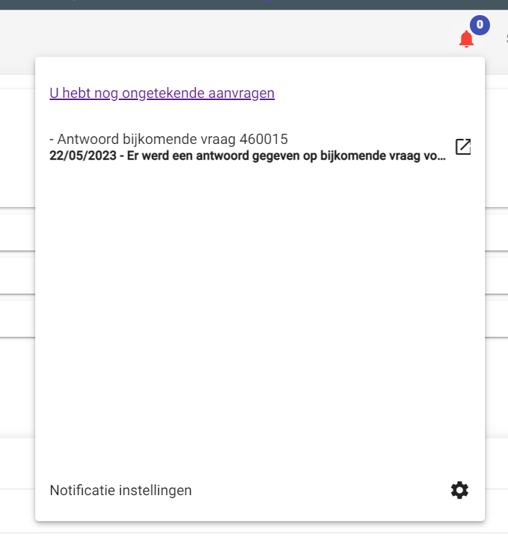

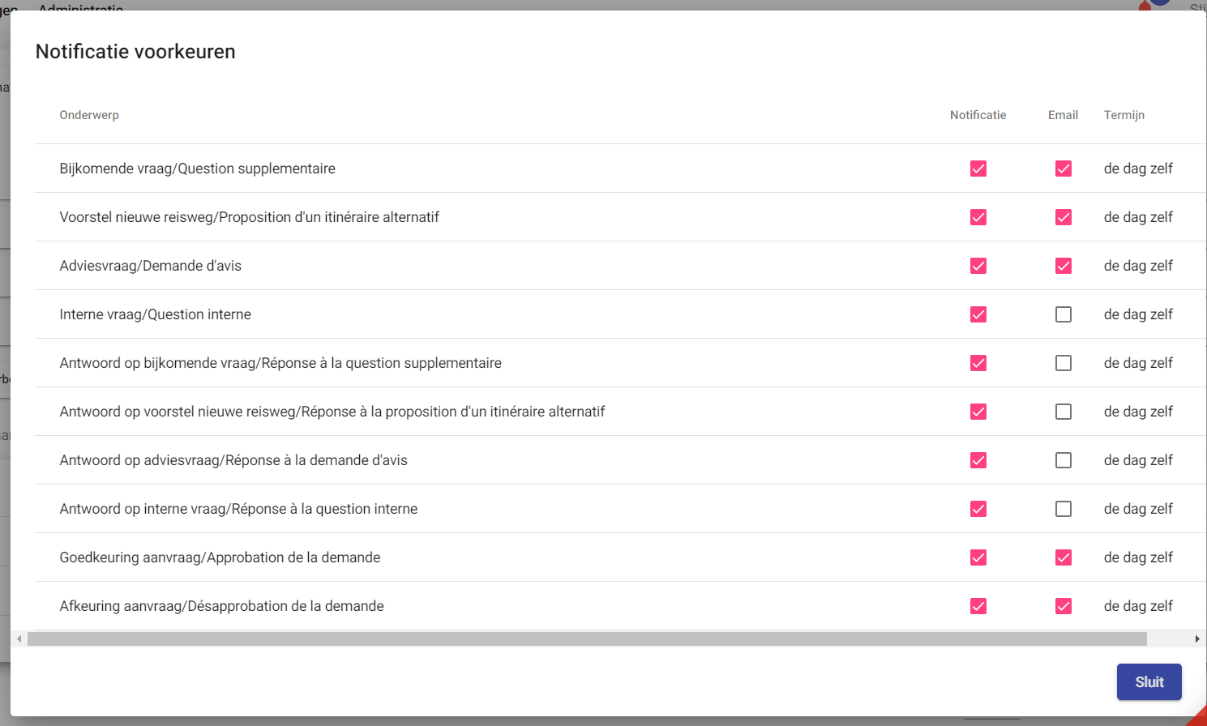

Signing
Once you have completed a request, you can submit the file. The file will then appear in the list of unsigned requests. You will no longer receive an e-mail with a PDF file. Depending on the settings, the company in question will receive an e-mail notifying them that there is an unsigned request.

The unsigned requests screen:
You go to the unsigned requests screen through:

Answering “yes” to this will take you to the screen where you can sign the unsigned requests.
You will also go to that screen if you:
- Answer “yes”, when submitting a request, in the dialogue box asking whether you want to sign the request immediately.
- In the notifications section, you click on the message “There are unsigned requests”.
- Using the top left button; requests; Unsigned requests.
On that screen, you can view the contents of the file (link via the request number) and effectively sign off the file by clicking on the icon to the left of the file number.

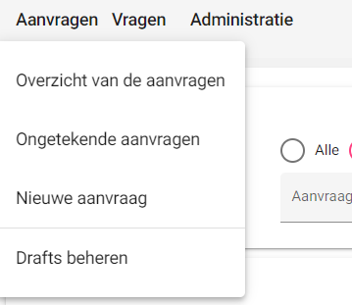

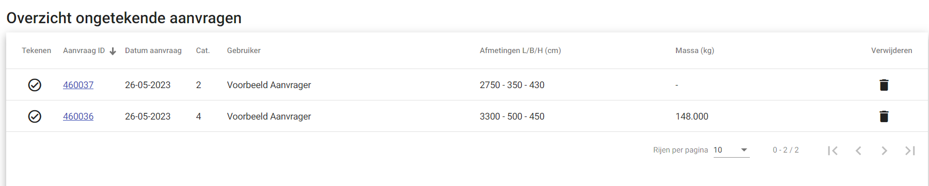

Adding attachments
Until now, you have not had the opportunity to add attachments to the file. From now onwards, you can.
Go to “requests overview”, select “outstanding files” and find the file you want to add attachments to. 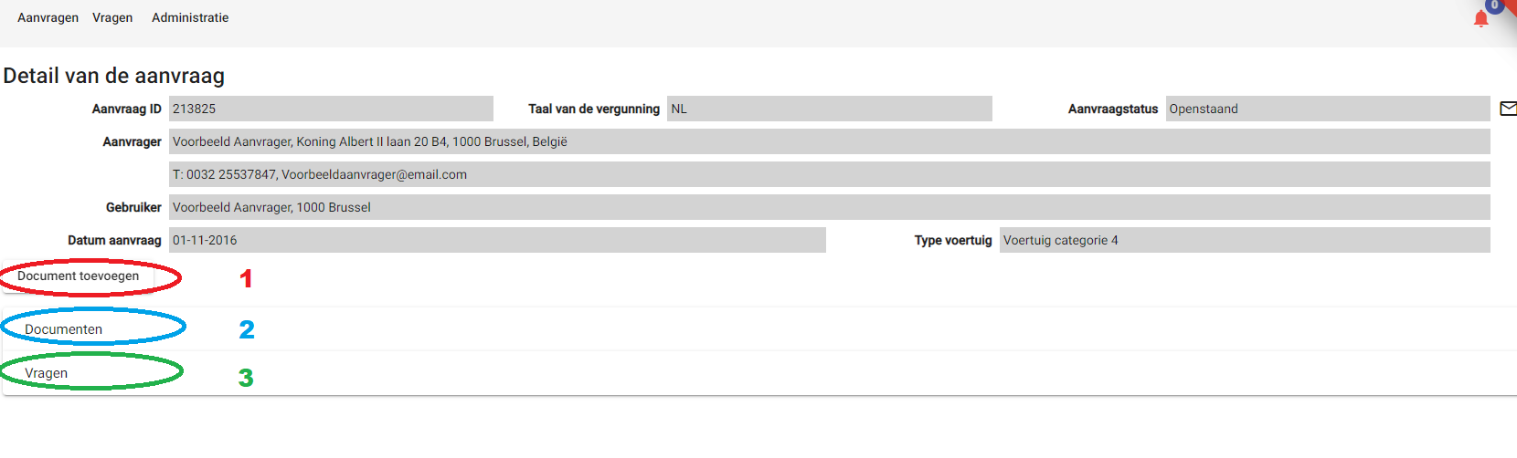On this screen, you will find the button “Add document”. Red Ellipse, no. 1.
This button will take you to the dialogue box for adding an attachment.
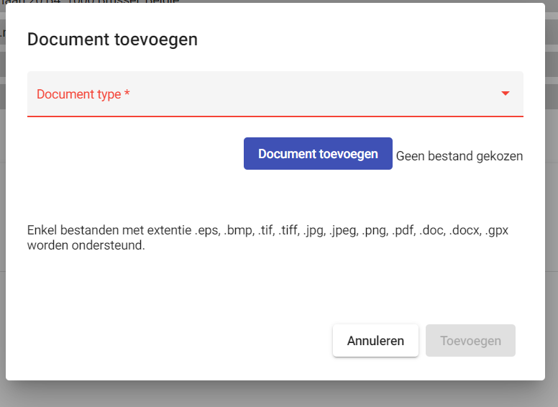
You choose a document type:
- Situation - everything related to the itinerary, route, etc.;
- Technical - everything related to the vehicles;
- Other - anything that does not fit into the previous categories
The chosen type does not matter for the further progress of the file.
Then you choose to add a document, after which you can pick a file using the computer’s explorer function.

Clicking ‘Add’ will upload the document.

The documents bar
If you click on the ‘Documents’ bar (ellipse 2) on the ‘request Detail’ screen, you will see your attachment, among other things. Here, you can also check what exactly you have requested so as to formulate an answer to an additional question.
Under the submitted files, you will see the document “Licence Request_Signed” (the document you have signed). Under the approved files, you will see the “Licence_Signed”. The actual licence.

The questions bar
Clicking on the ‘Questions’ bar (ellipse 3) will display all questions.
If there is a pending question, you can reply via the link (name recipient).

Additional question
PDF files that were sent out before 26 May 2023 are no longer usable.
You need to go to the file in WebTEUV, look up the question there and activate the dialogue screen.
On that dialogue screen, you can formulate the answer. On that screen, you cannot add an attachment.
Should you wish to add an attachment, you can do so on the ‘File Detail’ screen. How to do that is described above.

Looking up a file
This is the request’s home screen.
At the top, you have the menu bar (Red Ellipse 1).
This window is the one corresponding to ‘requests’ - ‘File Overview’.
You will obtain a list of all files meeting the conditions you have entered.

Using the buttons in the green ellipse 2, you can select the request status. If you are looking for an approved file, then select ‘approved’.
If you have a file number, you can enter it at ‘request ID’.
You can further refine the search using the bars: vehicles, dates and road number.
Then press the ‘Search’ button (blue ellipse 3).
That way, you will get an overview of all files that meet all imposed conditions.

Starting a new file

Via ‘Copy’
You can search for a file using the method described above.
E.g. status: approved
Vehicles: Category 2
Dates: Approval date between <<date next week - 1 year>> and <<date in 14 days - 1 year>>
=> The result will be all files that will expire between next week and 14 days. You may have to reapply for these licences.
You can do that by selecting one file (tick the licence box). At the bottom, the ‘New request by copy’ button will become active.
This way, the system will fill in all screens the same way the selected licence was delivered previously.
If no adjustments are needed, you can ‘Send’ the file immediately.

Entirely new file
Via a new request:
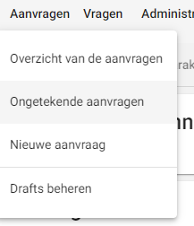
In that case, you will have to fill in all screens.
You can pause completion and save your work as a draft (only people within your organisation can see this).
You can also start compiling your request from a draft (via ‘Manage Drafts’).

